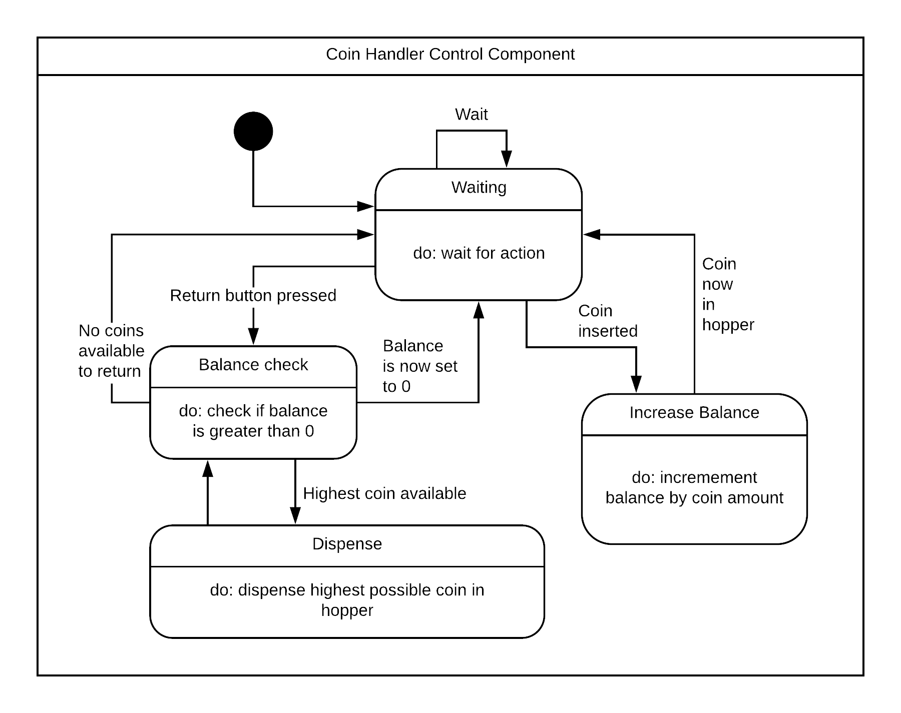

|  |  |
| --- | --- |
| Stimulus | Description |
| Waiting | Waits for the user’s action |
| Increase Balance | Increases the balance of the user when they input a coin |
| Balance Check | If the balance is greater than 0 then should return coins |
| Dispense | The machine dispenses the highest coin possible to the user. |

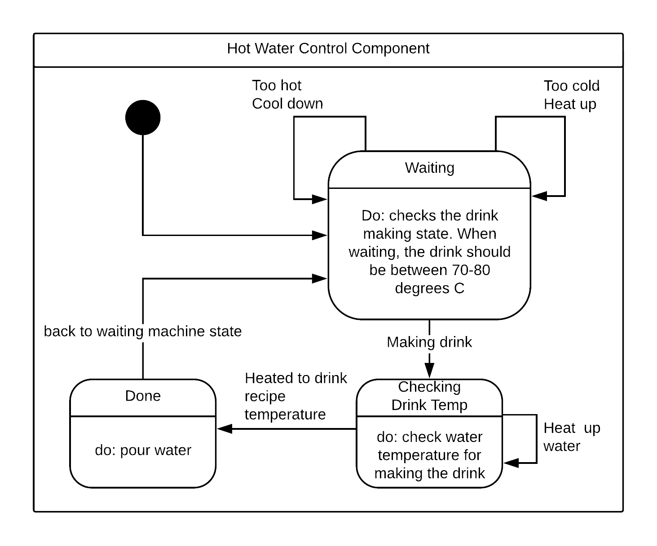

|  |  |
| --- | --- |
| Stimulus | Description |
| Done | The heater has gone to the sufficient temperature and now is ready to pour the water. The machine then returns to its idling state until the next user wants to |
| Checking Drink Temp | Checks if the drink temperature is optimal before it starts to pour |
| Waiting | This is the IDLE state. The machine’s water temperature checks if it is between 70-80 degrees c. If it is too hot, it turns the heater off. If it is too cold, it turns the heater on. It leaves this state when the user starts to make a drink. |